Azure Monitor Metrics type:

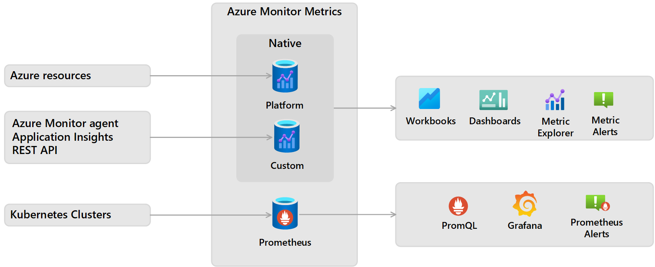

VM Host Data & VM Guest Data:
VM host data: VM host data is available without additional setup.
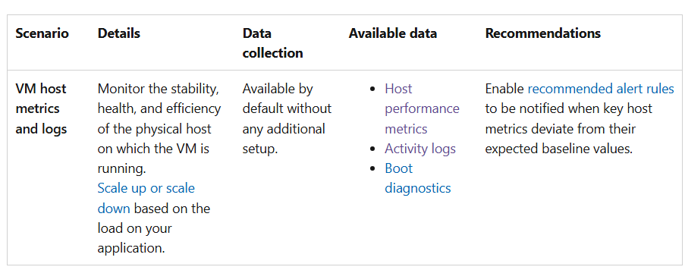

VM Guest data:
VM guest data lets you analyze and troubleshoot the performance and operational efficiency of workloads running on your VMs. To monitor VM guest data, you need to install Azure Monitor Agent on the VM and set up a data collection rule (DCR). The VM Insights feature automatically installs Azure Monitor Agent on your VM and sets up a default data collection rule for quick and easy onboarding.

